**DIGA 2017 TEAM 3:**

Gabriel Quirschfeld (project leader)

Aatu Mikkonen

Teemu Kolu

**FOREST INDICATOR SERVICE**

PROJECT CLOSING REPORT VERSION 0.01

THE VERSION HISTORY OF THE DOCUMENT

|  |  |  |  |
| --- | --- | --- | --- |
| VERSION No. | DATE | REASON FOR CHANGE | AUTHOR/ACCEPTOR |
|  |  |  |  |
| 1.0 |  |  |  |
| 0.1 | 13.12.2017 | Initial creation |  |

LIST OF CONTENTS

LIST OF CONTENTS 3

1 THE DESCRIPTION OF THE PROJECT 4

2 RESULTS OF THE PROJECT 4

2.1 Description of the System 4

2.2 Description of the Application 5

2.3 Description of the Platform 6

3 GENERAL EVALUATION OF THE PROGRESSION OF THE PROJECT 6

4 THE EXPERIENCES OF THE USED TOOLS AND METHODS 6

5 PERSONAL EXPERIENCES AND LEARNING 7

5.1 Gabriel’s experiences 7

5.2 Aatu’s experiences 7

5.3 Teemu’s experiences 7

REFERENCES 8

# THE DESCRIPTION OF THE PROJECT

The goal of this project is to produce a web based application that presents the data found in Luke’s MELATuPa -service. The interface is to be made using React, and the final application should be hosted on Google Cloud Platform. For accessing the data, a REST interface is available. The purpose of the Forest Indicator service is to promote multiple and sustainable use of forests by producing information about the effects of forest use at regional level for the planners and other users.

Our team had very little previous experience with React, so we had to learn much during the project. In the end the project output was a feature complete web application, with most of the functions working with little flaws.

# RESULTS OF THE PROJECT

## Description of the System

The application will function as an interface of a bigger system meant to access and display data in the MELATuPa -database (Figure 1). This is done by using a REST API, which was made available to us at the start of the project. Our application queries information from the REST interface, which in turn fetches the data from MELATuPa. The data returned by the API is then displayed on the users screen.

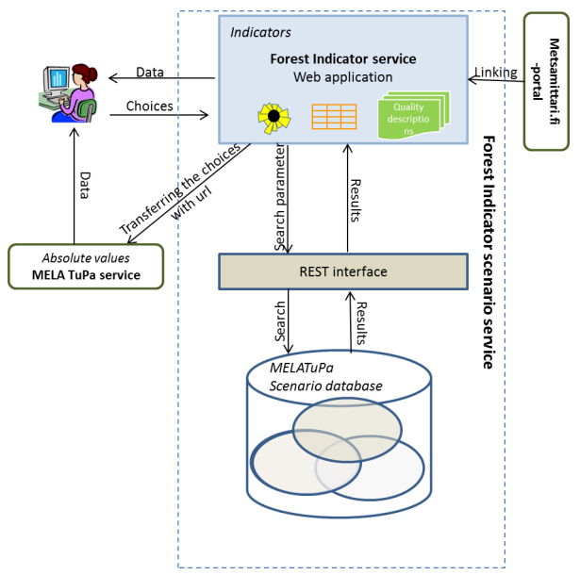

FIGURE 1. Connection of the Forest Indicator service and MELATuPa

## Description of the Application

The main layout and most UI elements are made with React, for which some node modules were required. For example, the dropdown menus are made using the “react-selectize” node module. Drawing the charts was done using the React version of Highcharts, “react-highcharts”. Some extra styling of the page was done with Bootstrap.

The application queries data from the Rest API based on the users selections on the dropdown menus. When appropriate selections are made, a graph will be displayed for the user to view.

## Description of the Platform

The application is deployed on the Google Cloud Platform.

# GENERAL EVALUATION OF THE PROGRESSION OF THE PROJECT

For organizing the project, Trello was used to assign tasks for different members of the team. Hour-tracking was done using a folder in the classroom, where each member marked their comings and goings. For our group the deadline that was set seemed a bit tight, but we managed to meet most of the requirements that were set at the start.

# THE EXPERIENCES OF THE USED TOOLS AND METHODS

For most of the group React was a whole new experience, so we had to learn it as we went. It seems like a good tool, but more time would be needed to become proficient. Coding the application was mostly done using Visual Studio Code.

Google Cloud Platform was another new thing on this project, but using it was easy enough with the given instructions.

# PERSONAL EXPERIENCES AND LEARNING

## Gabriel’s experiences

I've started the work on the project with no prior experience in ReactJS other than the theory classes at the beginning of this course. By the time we were finishing the project I have found the framework enjoyable and relatively straightforward to use.

The project itself was fun to work on, I have learned a lot of useful information about ReactJS, team work and even CSS. My team collaborated very nicely and I was glad that I could have worked with them.

## Aatu’s experiences

Starting this course without any former experience of ReactJS made things harder than expected and not being in the theory courses hurt as in learning the whole thing took way longer than anticipated.

In the time as I was learning about the framework, I did some small stuff in the side like the basic look of the page and simple things, like making a page look good when printed.

I feel like the time we had was not enough as learning a new framework takes time and there was a bit too little theory classes on this.

The project was a fun and educating experience, learning a new thing with good people made the project work that much more enjoyable.)

## Teemu’s experiences

As I had no previous experience with web development, this project was pretty challenging to me, but a good learning experience. My responsibilities for the project were fetching the data, Git management and switching the language.

I felt that the deadline for the project was a bit too strict, but other than that it was a well lead project. Having a good team also helped.

REFERENCES

1. RequirementSpecification Forest Indicator 1.13. 2017. Project requirements. Luke.